CC2020 report – page 49

4.2.4: Component Elements

A competency is a collection of specific components of knowledge, skills, and dispositions. Tables 4.1, 4.2, 4.3, and 4.4 present suggested elements of these dimensions. The knowledge dimension of competency encompasses concepts that are technical (computing concepts), foundational and professional (indicative of a workplace), and domain specific (the task setting). Appendix D elaborates on these component tables in greater detail.

Table 4.1 illustrates thirty-four abbreviated knowledge areas partitioned into an ordered sequence of six categories.

While the table is incomplete, it does provide an example of high-level vocabulary for computing knowledge rooted in the collective wisdom of different computing communities.

This summary of computing knowledge areas represents a well-understood and consistent vocabulary from which computing competency statements can evolve.

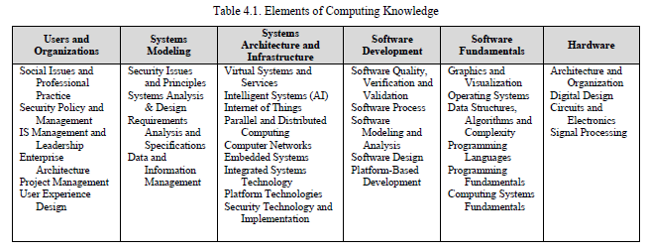

The thirteen elements of foundational and professional knowledge listed in Table 4.2 represent a subset of the professional listings derived from the IT2017 report and subsequently from Appendix D in this report. Computing professionals are commonly expected to demonstrate high levels of skill in applying this knowledge which desserves explicit attention in baccalaureate programs.

Domain knowledge represents elements of the context that situates the task. In the general, these elements may represent the disciplinary (e.g., business, medicine, manufacturing). In the more detailed, they may be more specific (e.g., international currency exchange, radiographic imaging, automobile assembly). In any case, the scope and level of detail of domain knowledge will emerge from the intended use of the competency (i.e., Computing + X or X + Computing, for which see Section 2.4).

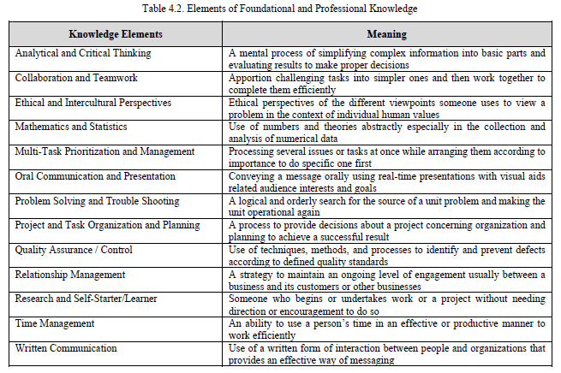

4.2.5: Creating Competency Statements

The competency model adopted in this CC2020 Report suggests that statements surrounding competency include knowledge elements paired with skill level and with dispositions. The following examples demonstrate a way to do this. Each of the three example competencies that follow specifies a statement of the task to be undertaken and itemizes the components deemed pertinent to effectively and efficiently accomplishing that task.

- CC2020Report pag 51

Competency Title: A

Competency Statement
Manage the design of a computer system for a manufacturer using appropriate tools, design digital circuits including the basic building blocks of Boolean algebra, computer numbering systems, data encoding, combinatorial and sequential elements.

Pair Knowledge Element x Skill Level
Architecture and Organization x Creating
Digital Design x Creating
Circuits and Electronics x Creating
Analytical and Critical Thinking x Applying
Mathematics and Statistics x Applying
Problem Solving and Trouble Shooting x Applying
Research and Self-Starter/Learner x Applying

Disposition(s)
Self-directed, Meticulous, Inventive

Competency Title: B

Competency Statement
Analyze and compare several networking topologies in terms of robustness, expandability, and
throughput used within a cloud enterprise.

Pair Knowledge Element x Skill Level
Computer Networks x Analyzing
Platform Technologies x Analyzing
Analytical and Critical Thinking x Applying
Mathematics and Statistics x Applying
Quality Assurance Applying

Disposition(s)
Self-directed, Purpose-driven, Responsible

Competency Title: C

Competency Statement
Identify and document system requirements by applying a known requirements elicitation
technique in work sessions with stakeholders, using facilitative skills, as a contributing member
of a requirements team.

Pair Knowledge Element x Skill Level
Requirements Analysis x Evaluating
Oral Communication x Applying
Written Communication x Applying
Teamwork and Collaboration x Applying

Disposition(s)
Purpose-driven, Responsible, Collaborative

